Project 1 Checkpoint 1 – Due Monday 1st of June

Add a file to your project repository that includes the following pieces of information:

* Project ERD rendered through DBeaver.
  + This is proof that you’ve completed the database setup.
* API Specification
  + Shows you’ve thought out your API.

Sample:

ERD Diagram

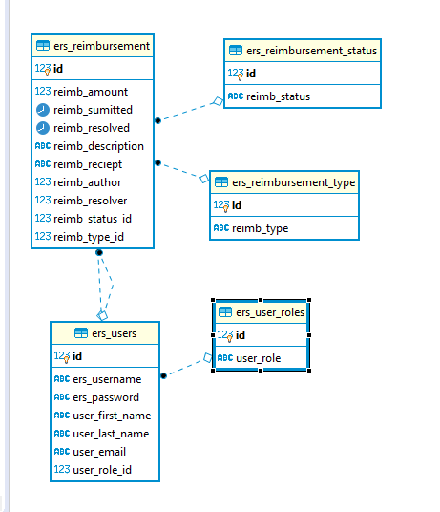

API Design

* users
  + GET /users - retrieves all user in database
  + GET /users/:id – Retrieves user by id
  + POST /users – Adds new user to database
  + PATCH /users – Updates user
  + DELETE/users/:id -delete user
* reimbursements
  + GET /reimbursements - retrieves all reimburse in database
  + GET /reimbursements/:id – Retrieves reimburse by id
  + POST /reimbursements – Adds new reimburse to database
  + PATCH /reimbursements – Updates reimburse
  + DELETE/reimbursements/:id -delete reimburse
* status
  + GET /status/:id – Retrieves status by id
  + POST /status – Adds new status to database
  + PATCH /status – Updates status
* roles
  + GET /roles/:id – Retrieves roles by id
  + POST /roles – Adds new roles to database
  + PATCH /roles – Updates roles
  + DELETE/roles/:id -delete roles
* types
  + GET /types/:id – Retrieves types by id
  + POST /types – Adds new types to database
  + PATCH /types – Updates types
  + DELETE/types/:id -delete types